Microprocessor and Interfacing project 2017

Smart Garage System

BIRLA INSTITUTE OF TECHNOLOGY AND SCIENCE,

PILANI

PILANI CAMPUS

PROJECT NUMBER: 21

GROUP NUMBER: 10

Yash Bansal : 2014B2A7238P
Aman Gupta : 2014B2A7358P
Abhishek Jain : 2014B2A7363P
Subham Swastik Dora : 2014B2A7644P

Problem Statement:
To design a Smart Garage System to be used in an underground parking of a hotel with a maximum capacity of 2000 cars.A remote unit for opening and closing of hte garage door would be with every user of the garage.The remote unit has only one button.A LCD display would available indicating the number of cars in the garage.
System runs from a standard power inlet available in the garage.Full and empty status will be shown through an LED.

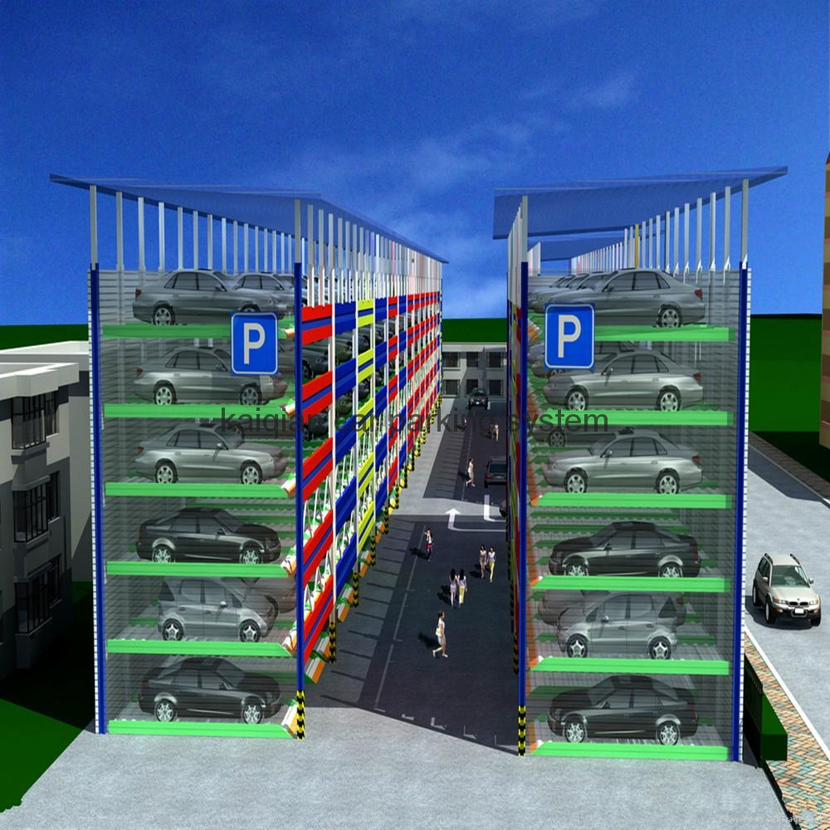

Specifications:

- Remote unit button toggles the condition of the garage door- i.e. if the door is opened it is closed and vice versa.
- The remote unit is used for short distances only.
- A DC motor is used for opening and closing the door.The motor is a 50V ,3 A motor.
- The system distinguishes between a person and a car using a switch that can be
closed only by the weight of a car.
- System is used in the hotel- so you can assume that a valet parking system is followed this indicates that only one person leaves the garage after the car is parked and only a single person enters the garage to retrieve the car
- The system also has to distinguish between entry and exit by using two IR sensors on either side of the gate. Depending on the sequence in which the sensors are triggered (by man\car), an entry or exit is recorded and the count of vehicles is changed accordingly in case of cars.
- Whether a car enters or a valet enters the door remains open for a period of five minutes. During these 5 minutes the system keeps checking if the remote is triggered.
- The door can close after 5 Minutes or when the valet uses the remote.
- The remote can be used inside as well as outside the garage.
- An LCD screen (LM016L) is used to display the count of cars in the garage while an LED screen displays “FULL” when there are 2000 cars and “EMPTY” when there are no cars.

Components Used

Microprocessor  4 KB ROM chips  2 KB RAM chips  PPI  TIMER  LCD display  LED Display  3to 8 line Decoder  AND gates  OR gate  NOT gate  Motor Driver  Motor  Bidirectional buffer  Unidirectional buffers  Unidirectional latches  Clock Generator  Comparator IC  IR receiver  Weight Sensor | INTEL 8086  2732  6116  8255  8253  LCDLM016L  74LS138  7408  7404(six )  LS239D  50 V , 3A  74LS245  74LS244  74LS373  8284  LM139  TSOP 1738 | 1  4  2  2  2  1  2  2  1  6  2  1  1  2  2  3  1  1  3  1

ALGORITHM:

- To determine if a car/person is entering or leaving IR sensors are placed on both the inside and outside of the garage.

- The heavier car is differentiated from a person by using pressure transducers.

- A remote is also used for opening and closing of the garage. The sensors and
remote signals are continuously checked for any valid input. A user can press the remote to open or close the garage.

- A count is kept for the number of cars in the garage which is updated whenever a car enters or leaves the garage. This count is displayed on the LCD screen and if the count is 2000, a red LED glows whereas in the case of 0, a green LED glows.

- Whenever a door is opened using a remote, it can be closed by pressing the remote again. Otherwise, it will automatically close after 5 minutes.

- When a car wants to enter the garage, then the user presses the remote. This
would open the gate using the motor and the car can enter the garage. The door
will remain open till the remote is again pressed else it will automatically close in 5minutes. The count of cars will be updated.

- Whenever the valet wants to enter or leave the garage, the remote has to be
pressed.

- When the car wants to leave the garage, the remote is pressed by the user. This
would close the gate using the motor and the car can leave the garage. The door will remain open till the remote is again pressed else it will automatically close in 5minutes. The count of cars is updated.

Assumptions:

- The garage is initially empty and the garage door is closed.
- Voltage reference for weight(force) sensor is 0.5V
- Voltage reference for IR sensors is 0.2V.
- The LED shows GREEN when the garage is empty, and shows RED when it is full, otherwise both wont light up.
- The remote is enabled manually by us on Proteus using buttons.

Memory Mapping:

Memory Interfacing Devices

ROM1_Even -> 00000h-01FFEh
ROM1_Odd -> 00001h-01FFFh
RAM1_Even -> 02000h-02FFEh
RAM2_Odd -> 02001h-02FFFh
ROM2_Even -> FE000h-FFFFEh
ROM2_Odd -> FE000h-FFFFFh

8255
PORT A -> 00h
PORT B -> 02h
PORT C -> 04h
CONTROL REGISTER -> 06h

Timer
COUNTER1 -> 08h
COUNTER2 -> 0Ah
COUNTER3 -> 0Ch
CONTROL REGISTER -> Oeh

Timer 2
COUNTER 1 -> 10h
COUNTER 2 -> 12h
COUNTER 3 ->14h
CONTROL REGISTER->16h

Assignment of Input Ports
PA0->Remote Input
PA1->Outer_IR Input
PA2->Transducer(Weight Sensor)
PA3->Inner_IR Input
PA4->Remote Timer

Flow Chart:

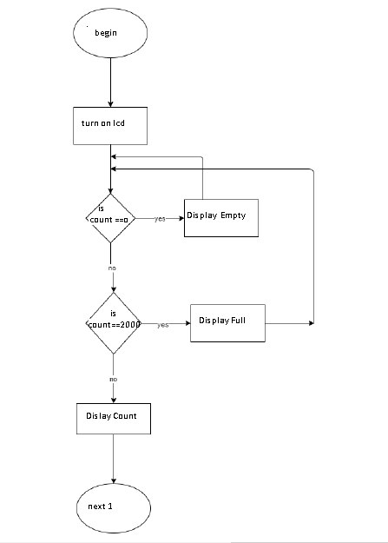

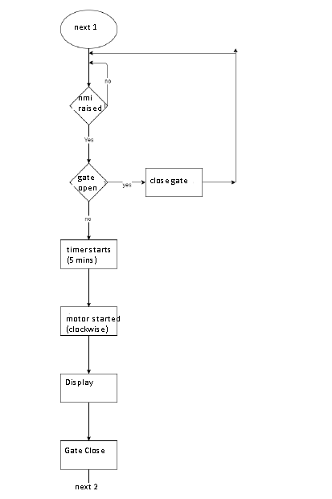
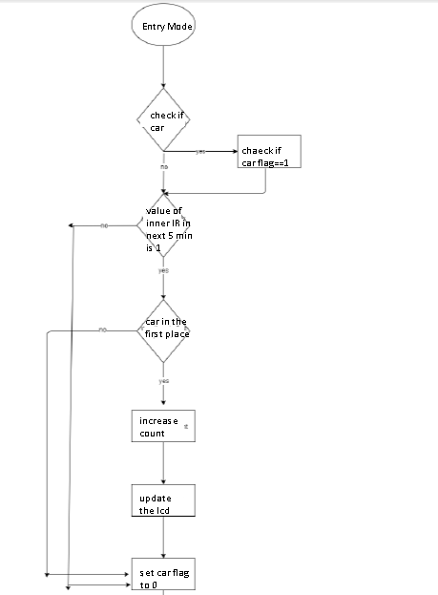

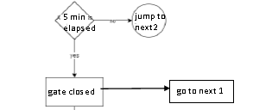
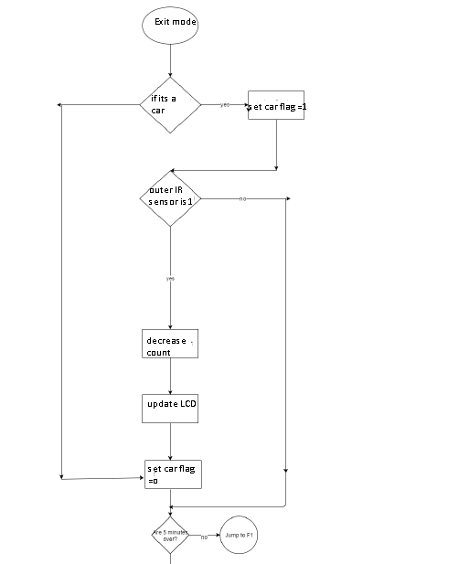
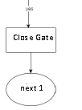

ASM CODE :

.model tiny
.8086
.data

strlen db 0
empty db 'EMPTY'
full db 'FULL'
count dw 0

;assigning port addresses
inadd_word equ 00h
lcd_data equ 02h
lcd_motor_control equ 04h
creg_io equ 06h

timer_clock equ 08h
timer_remote equ 0ah
timer_door equ 0ch
creg_timer equ 0eh

timer_clock2 equ 10h
timer_remote2 equ 12h
timer_door2 equ 14h
creg_timer2 equ 16h

jmp st1
db 1024 dup(0)

.code
.startup

st1:

mov cx, 0000h
mov bx, 0000h
mov dx, 0000h

inits:

mov ax,0200h
mov ds,ax
mov es,ax
mov ss,ax
mov sp,0FFFEH

mov al,10000000b
out creg_io,al

mov al, 00110110b
out creg_timer, al
mov al, 0A8h ;10101000
out timer_clock, al ;Timer 1 intialize
mov al, 61h ;01100001
out timer_clock, al

mov al,00110011b ;Timer 2 intialize
out creg_timer2,al

call lcd_init
call lcd_update

garageclosed:
in al, inadd_word
and al, 00000001b
cmp al, 1
je opendoor
jmp garageclosed

garageopen:
mov cl,0
mov ah, 0 ; reset car flag to 0
in al, inadd_word
mov bl, al
and bl, 00000001b
cmp bl, 00000001b ; check for remote press
je closedoor
mov bl, al
and bl, 00010000b
cmp bl, 00010000b ; check for timeout (5 minutes)
je closedoor
mov bl, al
and bl, 00000010b
cmp bl, 00000010b ; check for outer IR
je entering
mov bl, al
and bl, 00001000b
cmp bl, 00001000b ; check for inner IR
je exiting
jmp garageopen

closedoor:
call motor_clockwise
call motor_start
call start_door_timer
stillclosing:
in al, inadd_word
and al, 00100000b
cmp al, 00100000b ; wait for door to close completely
jne stillclosing

call motor_stop
jmp garageclosed

opendoor:
call start_remote_timer
call motor_anticlockwise
call motor_start
call start_door_timer

stillopening:
in al, inadd_word
and al, 00100000b
cmp al, 00100000b ; wait for door to open completely
jne stillopening

call motor_stop
jmp garageopen

entering:
mov cl,0
in al, inadd_word
mov bl, al
and bl, 00000001b
cmp bl, 00000001b
je closedoor
mov bl,al
and bl, 00010000b
cmp bl, 00010000b ; check for timeout (5 minutes)
je closedoor
mov bl, al
and bl, 00000100b
cmp bl, 00000100b ; check for car
jne nc00
mov ah, 1
nc00:
mov bl, al
and bl, 00001000b
cmp bl, 00001000b ; check for inner IR
jne entering
cmp ah, 1
jne nc01
inc count
call lcd_update
nc01:
in al, inadd_word
mov bl, al
and bl, 00001000b
cmp bl, 00001000b ; debounce
je nc01
jmp garageopen

exiting:
mov cl,0
in al, inadd_word
mov bl, al
mov bl, al
and bl, 00000001b
cmp bl, 00000001b
je closedoor

and bl, 00010000b
cmp bl, 00010000b ; check for timeout (5 minutes)
je closedoor

mov bl, al
and bl, 00000100b
cmp bl, 00000100b ; check for car
jne nc10

mov ah, 1
nc10:
mov bl, al
and bl, 00000010b
cmp bl, 00000010b ; check for outer IR
jne exiting
cmp ah, 1
jne nc11
dec count

call lcd_update
nc11:
in al, inadd_word
mov bl, al
and bl, 00000010b
cmp bl, 00000010b ; debounce
je nc11
jmp garageopen

lcd_init proc near
mov al, 00001111b
out lcd_data, al
mov bl, 00100000b
call setlcdmode
mov bl, 00000000b
call setlcdmode
ret
lcd_init endp

lcd_update proc near
call lcd_clear
mov al, ' '
call lcd_add_lcd
cmp count, 0
jnz notempty
lea di, empty
mov strlen, 5
jmp loaded
notempty:
cmp count, 2000
jnz notfull
lea di, full
mov strlen, 4
jmp loaded
notfull:
call lcd_bcd
ret
loaded:
call lcd_add_word
ret
lcd_update endp

lcd_bcd proc near
mov ax, count
mov cx, 0

converting:
mov bl, 10
div bl
add ah, '0'
mov bl, ah
mov bh, 0
push bx
inc cx
mov ah, 0
cmp ax, 0
jne converting

printing:
pop ax
call lcd_add_lcd
loop printing
ret
lcd_bcd endp

lcd_add_word proc near
mov cl, strlen

putting:
mov al, [di]
call lcd_add_lcd
inc di
loop putting
ret
lcd_add_word endp

lcd_add_lcd proc near
push ax
out lcd_data,al
mov bl,10100000b
call setlcdmode
mov bl,10000000b
call setlcdmode
pop ax
ret
lcd_add_lcd endp

lcd_clear proc near
mov al, 00000001b
out lcd_data, al
mov bl,00100000b
call setlcdmode
mov bl,00000000b
call setlcdmode
ret
lcd_clear endp

setlcdmode proc near
in al, lcd_motor_control
and al, 00011111b
or al, bl
out lcd_motor_control, al
ret
setlcdmode endp

start_door_timer proc near
mov al, 10110000b
out creg_timer, al
mov al, 90h
out timer_door, al
mov al, 01h
out timer_door, al
ret
start_door_timer endp

start_remote_timer proc near
mov al, 01110000b
out creg_timer, al
mov al, 30h
out timer_remote, al
mov al, 75h
out timer_remote, al
ret
start_remote_timer endp

motor_stop proc near
in al, lcd_motor_control
and al, 11111100b
or al, 00000000b
out lcd_motor_control, al
ret
motor_stop endp

motor_anticlockwise proc near
in al, lcd_motor_control
and al, 11111100b
or al, 00000001b
out lcd_motor_control, al
ret
motor_anticlockwise endp

motor_clockwise proc near
in al, lcd_motor_control
and al, 11111100b
or al, 00000010b
out lcd_motor_control, al
ret
motor_clockwise endp

motor_start proc near
in al,0cah
out timer_clock2,al
in al,08h
out timer_clock2,al
in al,0d4h
out timer_clock2,al
in al,30h
out timer_clock2,al
ret
motor_start endp

.exit
end

